10 FEBRUARY 2014
DALE COLLETT SCR
PO Box 43 Gaborone Botswana
Mokgotloadisa Ward Bokaa
Tel: +267-316-4169 (W)
Fax: +267-318-7788
Cell: +267-7131-1619
E-mail: dale@dalecollett.co.bw
Mr. Tom Thomas
Selous Scouts Association South Africa
Dear Tom,
A MOTORCYCLE RIDE TO RAISE MONEY FOR “RAY OF HOPE”
I am planning to ride to Cape Town to visit my two sons who live there.
Many people are rather surprised by what I am going to attempt, so I thought I would ask a few of the big corporates if they would be interested in sponsoring me per kilometer which will go to “Ray of Hope”. The total distance to and around Cape Town and back again would be about 5000 km.
I would like to emphasise that this ride is also a personal challenge to me. I have had offers from other bikers to ride with me part of the way but I have requested all these kind folks to watch me struggle to repair a problem. Only when I am defeated will I call on their help.
Ray of Hope makes dreams come true for terminally ill children in Botswana. It might be a bicycle, it might be a trip to see wild animal, it might be a trip to the sea, maybe even to meet the President.

The route I am planning is as follows:
DAY 1
Gaborone, Vryburg, Kuruman. Total 451km.
DAY 2
Kuruman, Upington, Keimoes, Kenhard. Total 381km.
Day 3
Kenhardt, Calvinia, Tankwa Karoo. Total 439km.
Day 4
Tankwa Karoo, Simonstown . Total 277km.
TOTAL ON THIS ROUTE 1548km.

I will be carrying:
Wheelchair.
30 liters of fuel which should easily get me to the next fuel point.
20 liters of water for washing and drinking.
Spare wheel, spare tyre and 2 spare tubes.
Bike tools, jack, sockets, spanners.
Jumper leads, Tow rope.
Clothing.
Gas Cooker
Mess tin.
Food, tea, sugar.
Laptop, Camera & Gps
Sunblock.
Rainsuit.
Amongst many other items.

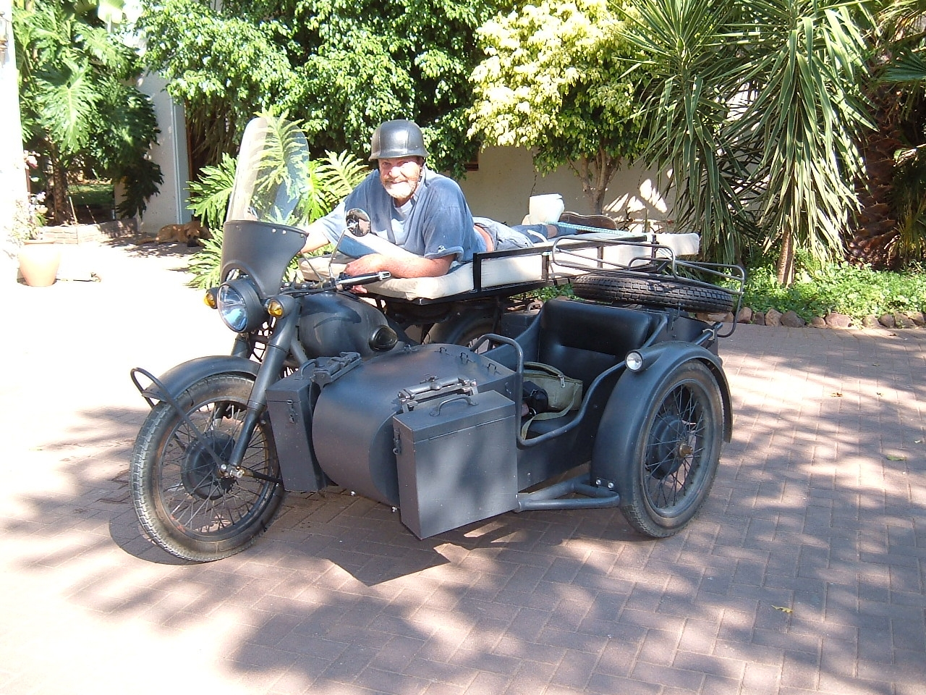

I will be living on the bike for these four days which includes washing on the bike, sleeping on the bike and hopefully updating a web page as I travel.

The cruising speed on this bike is between 70-80km/hr so it is slow by modern standards.

The bike was bought new but is old technology. I understand the technology is about 1956 so spares and tools should always be carried.

I am now 63 years old. I was paralysed in 1976 at the level T4 which is about level with your breastbone. I have suffered from many pressure sores over the years and I therefore drive my vehicle and motorbike lying down.
In September 2011 I broke my left leg very high up and decided to have it amputated.
In January I had an operation to my left shoulder to repair torn tendons but unfortunately they are irreparable.
To say that I need a complete overall would not be an exaggeration.

Why am I asking you to sponsor me per kilometer?
You and I get up in the morning and start complaining about the day, the traffic, colleagues, the heat, the drought, the poor salary, the cost of living and yet nearly every one of the kids that are supported by Ray of Hope never ever complain.
They sometimes go through painful treatment and never mutter.
They are often physically weaker but never give up.
They don’t have fun like other kids, they don’t go on outings and yet they are some of the bravest folks in our community.
Now to top all this, all of them have a terminal disease. That’s right, they are dying. It is simple, they are dying.
All I ask is that you pay an amount of your choice per kilometer towards Ray of Hope.
This puts additional pressure on me but my shoulders can carry that load if it is for the kids.
I will be keeping a log of the trip so should you sponsor Ray of Hope I will advise you on my return how much you owe.

Finally have a look at http://www.dalecollett.co.bw/ which is my personal web site.

When will this take place? I hope to leave on February / March 2014 but I have developed a small sore which seems to be responding well to treatment. I am seeing a specialist when he arrives in Gaborone. Nevertheless all sponsors will be advised.

Ray of hope have requested that I use another trust to collect their funds due to the main fund raiser / organizer being very over committed. I have requested Y-Care to administer the funds and they have readily agreed. Please ensure that all deposits must reflect “Ray of Hope” on the beneficiary statement when making payment to Y-Care.

Y-Care being a registered trust have kindly offered to assist in managing and distributing any funds donated.
Name: Y Care Charitable Trust
Account No: 2790902
Bank: Barclays Bank
Branch: Mall Branch, Gaborone
Branch code: 290167
SWIFT: BARCBWGX
“ I expect to pass through this life but once. If therefore, there be any kindness I can show, or any good thing I can do to any fellow human being, let me do it now, and not defer nor neglect it, as I shall not pass this way again. “ William Penn

Many Thanks.
Regards,
DALE COLLETT SCR

